Child Information Sheet

The Making Muscles Study

Why am I being asked to be in this study?

We want to find out if a new medicine can help you
and other kids with Duchenne Muscular Dystrophy.

The medicine is called Arkoft.

We want to find out if Arkoft
can help make your muscles stronger.

32 other kids like you will be in the study.

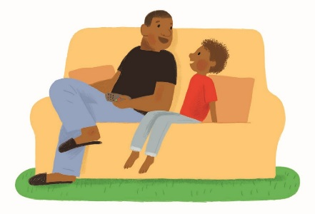
Do I have to be in this study?

[You and your parents should decide
if being in this study is the right thing for you.]

or

[You do not have to be in this study.
It is up to you whether you take part.

You can talk to your parents
about whether this study is right for you.]

If you change your mind after you start the study, talk to your parents.

If you leave the study, we will still look after you in the best way we can.
How long will I be in the study?

You will be in the study for up to 4 months.
You will visit the hospital about 8 times.
Each time you come to hospital we will give you a pill to take.
You will need to stay in the hospital
for 1 or 2 nights each time after we give you your pill.

What is in the pill you will give me?
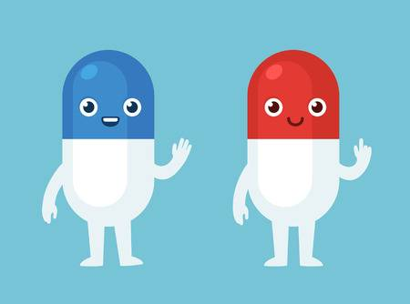
We will either give you a pill with medicine in it,
or a pill with no medicine in it.

The pill with the medicine will have Arkoft in it.

Arkoft is the medicine we are testing in this study.

Arkoft has been used safely on kids like you
in other countries like the United States.

In this study we are testing Arkoft on Australian kids.

The pill with no medicine in it is called a placebo.

We want to find out which pill works better.

Is it the pill with medicine or is it the placebo?

You will not know whether you are taking the pill with medicine
or the placebo.

Your parents and doctor will not know this either.

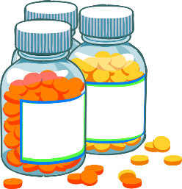
Can I take other medicines while I am in the study?

You will need to tell us about other medicines that you are taking.
This is so we can decide if they are alright.
You should not take any other medicines unless we say you can.

What will happen to me in hospital?

When you visit the hospital we will:
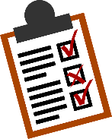
- ask you and your parents questions about your health

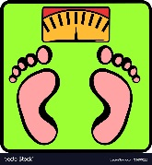
- look at you to see how tall you are and how heavy you are

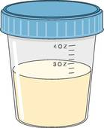
- collect samples of your wee. We also call this ‘urine’

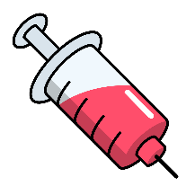
- put a needle in your arm to collect blood so we can test it

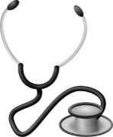
- listen to your heart and take your blood pressure

- check that your heart is working well using a special machine called an ECG

- give you a pill to take.

After you take this pill we will watch you to make sure you are ok.

Will the study hurt or make me feel sick?
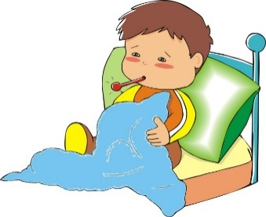
When you take the pill, you may get some side effects.
This means that the pill might make you feel sick.
This does not always happen.
It is important for you to tell us if you feel sick
or if something feels wrong.

If the pill is making you feel very sick,
we might give you something to try to take the sick feeling away.

We might also decide to stop giving you the pill.

When we take blood from you,
we will need to put a needle in your arm.

This might hurt a bit.
We can put a special cream on your arm to make it hurt less.
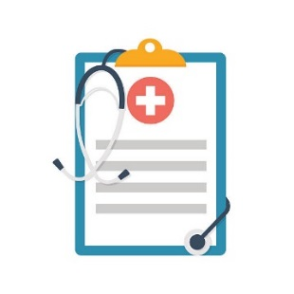
Who will get my information?

As part of this study we will write information about you
in your doctor’s notes.

Some of the people who will get copies of your notes are:

- your parents or the person taking care of you
- your doctor
- people working on this study.

Who can answer my questions?

If you have any questions, you can talk to us, the study team.
You can call the study doctor Dr Sam Siweke on 9292 3146.
You can also ask your parents to talk to us.

